EXPERIMENT 06
ROLL : 240701437 NAME : Rohith Nikethan P

RAD (Rapid Application Development) is a software development methodology that focuses on rapid prototyping and quick feedback rather than long planning cycles. It is highly suitable for UI/UX-based applications like mobile apps.
In this experiment, an Shoe ordering application is designed with an attractive and user-friendly interface.

Key Characteristics of RAD
- Focus on UI prototypes rather than heavy documentation
- Continuous user feedback and improvements
- Faster development cycles
- Reusable UI components
- Best suited for mobile app design

Phase 1: Requirements Planning
Objective
To design a mobile application for ordering shoe with an engaging and visually appealing interface.
Key Features
Navigation:
- Welcome Screen
- Home Screen
- Product Details
- Cart
- Checkout
User Actions:
- Browse shoes
- Search for items
- View product details
- Add items to cart
- Purchase items
Requirements
- Display welcome screen with branding
- Show list of shoes
- Provide detailed product description
- Add items to cart
- View total cart value
- Proceed to checkout
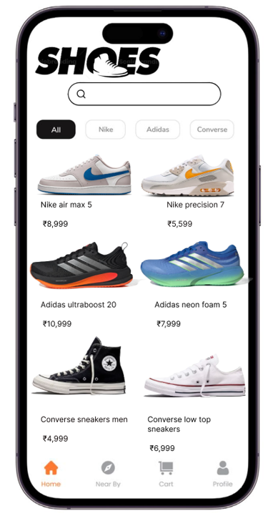

Phase 2: User Design
Wireframes Designed
- Home/Product Screen:
Shows shoe image, search bar, price, and description
- Product Details:
models,size,purchase options
- Cart Screen:
Displays selected items with price and total amount

Tools Used
- Figma (for UI design)
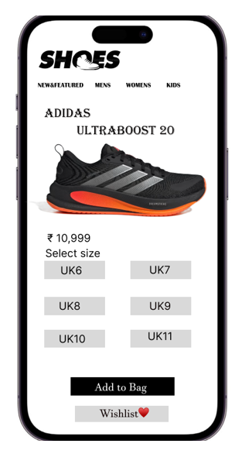

Phase 3: Construction
Prototype Flow
Welcome → Home → Product Details → Cart → Checkout
Dynamic Features
- Add to cart functionality
- Navigation between screens
- Price calculation in cart
Testing
- UI tested visually for consistency
- Improved button placement and readability
- Checked smooth navigation
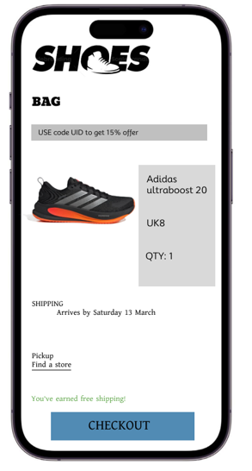

Conclusion
The Shoe Ordering App provides a visually rich and user-friendly experience. Using RAD methodology helped in quickly designing and refining the UI, ensuring better usability and faster development.

